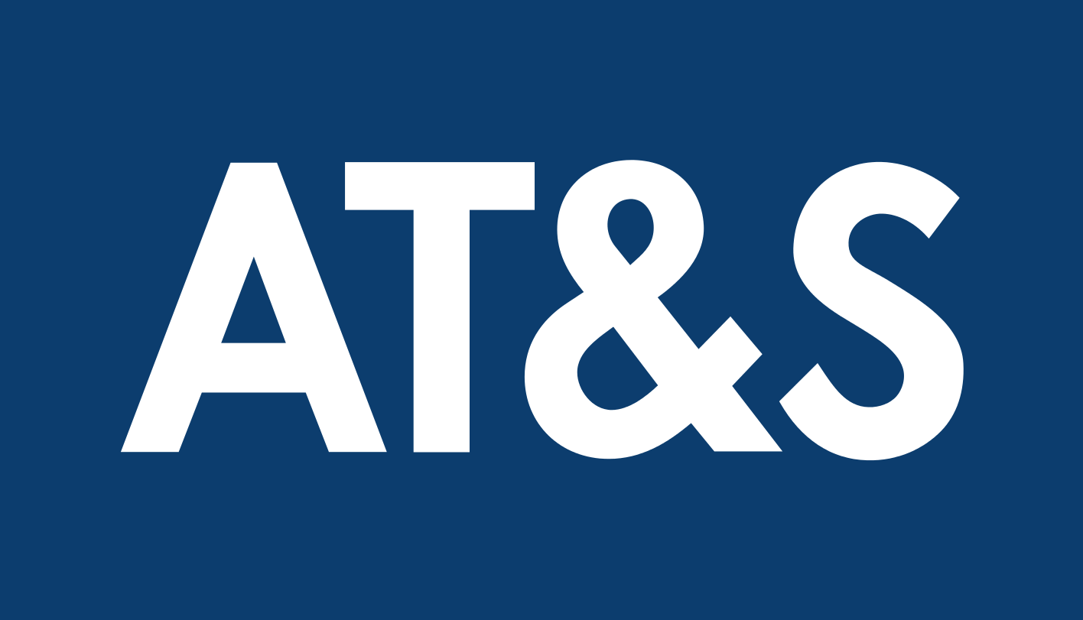

AT&S
Supplier Code of Conduct

19 April 2024
AT&S Board

AT&S SUPPLIER CODE OF CONDUCT
(Hereinafter also referred to as “code”)

Company name
Address
Country of place of Business

(including its affiliates, hereinafter collectively and individually referred to as "supplier")

INTRODUCTION

AT&S Austria Technologie & Systemtechnik Aktiengesellschaft, its subsidiaries and affiliates (collectively “AT&S”), being a responsible corporate citizen, has taken proactive measures to ensure the highest standards of professional and ethical business conduct.
AT&S recognises that the supply chain is a critical extension of our business value chain and actively strives to develop and work together with AT&S suppliers, contractors, agents, service providers and subcontractors (collectively, “Suppliers“) to achieve the goals referred to below.
AT&S is strongly committed to the Responsible Business Alliance (RBA) and its Code of Conduct (“RBA Code of Conduct”), as well as to internationally recognised standards, as for example and in particular the Universal Declaration of Human Rights (UDHR), standards issued by organisations such as the UN Global Compact, the OECD Guidelines for multinational enterprises, the International Labour Organization (ILO), Social Accountability International (SAI), and the Ethical Trading Initiative (ETI)).

PURPOSE OF THE RBA CODE OF CONDUCT

The purpose of the RBA Code of conduct is to ensure that working conditions in the electronics industry, as well as industries in or related to electronics industry supply chain, and their respective supply chains are safe, that workers are treated with respect and dignity, and that business operations are conducted in an ethical and environmentally responsible manner.
AT&S declares its support for the RBA Code and actively pursues conformance to the RBA Code and its standards, thereby acting as RBA participant (“participant”).
Additionally, following the requirements of the RBA, Participants must regard the RBA Code of Conduct as a total supply chain initiative with the goal to extend throughout and affect all of their supply chain. At a minimum, Participants shall also require its next tier suppliers to acknowledge and implement this Code.
AT&S expects its Suppliers to implement the requirements of the RBA Code of Conduct or an equivalent “down-the-supply chain” with its suppliers, contractors, services providers, agents and subcontractors.
AT&S requires that Suppliers comply with the RBA Code of Conduct by using adequate management systems as exemplarily described in the RBA Code of Conduct. Supplier’s status of compliance with the RBA Code of Conduct will be one of the considerations for AT&S in its decision-making on supplier evaluation and selection.

AT&S & SUPPLIER COMMITMENTS

Suppliers shall commit, in all their activities, to operate in a sustainable manner and in full compliance with all the laws, rules, and regulations of the countries in which they operate. Violations of the RBA Code of Conduct may result in immediate termination of the business relationship with the Supplier and in certain circumstances legal action.

THE Supplier acknowledges the code and agrees WITH AT&S, IN CONSIDERATION OF the SUPPLIER’S CONTINUING BUSINESS RELATIONSHIP WITH AT&S, and warrants towards AT&S that the Supplier and any of its worldwide affiliated companies will comply with the ethical standards and other requirements laid down in THE NEWESt valid version of the RBA Code of conduct (issued by the responsible business alliance under http://www.responsiblebusiness.org/code-of-conducT) during AN ongoing business relationship with AT&S.
The Supplier shall COMPENSATE, defend, indemnify and hold AT&S harmless from and againST any and all damages, liabilities and expenses (including reasonable attorneys’ fees), arising out of OR IN CONNECTION WITH a breach by supplier of thE RBA Code of Conduct or any claims by third parties related thereto.

Place, Date

Company name

Name:
Title:

